**BÀI ÔN TẬP MÔN ANH VĂN – KHỐI 1**

🕮 **Look and write**:

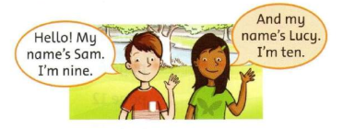

Sam: Hello! My name’s __________. I’m ________ .

Lucy: And my name’s ___________ . I’m ________ .

🕮 **Colors:**

**Sentences:**

1. What color is it?

It’s yellow.

is not = isn’t

1. Is it purple?

Yes, it is.

1. Is it pink?

No, it isn’t.

**READING AND WRITING 1**

**🖎** **I/ Answer the questions**

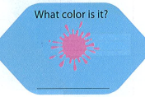 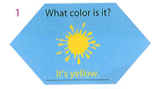

***It's pink***

Ex:

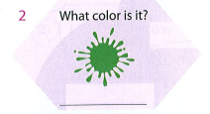 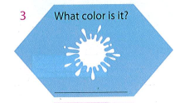

5.

4.

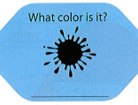 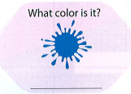

**🖎 II/ Answer the questions**

Ex: Is it orange? Yes, it is.

Is it brown? No, it isn’t.

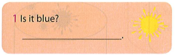 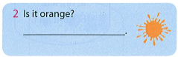

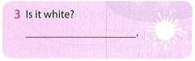 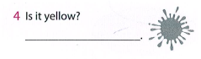

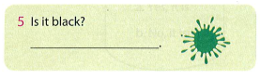 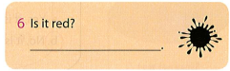

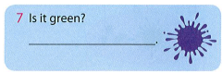 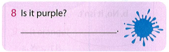

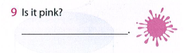

🕮 **Letter A a , B b , C c** and **D d**

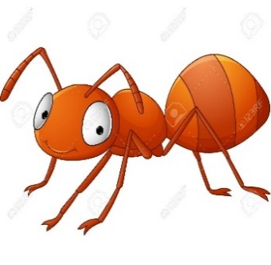

ant

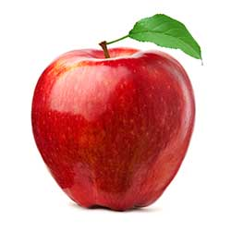

apple

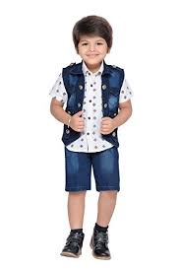

**boy**

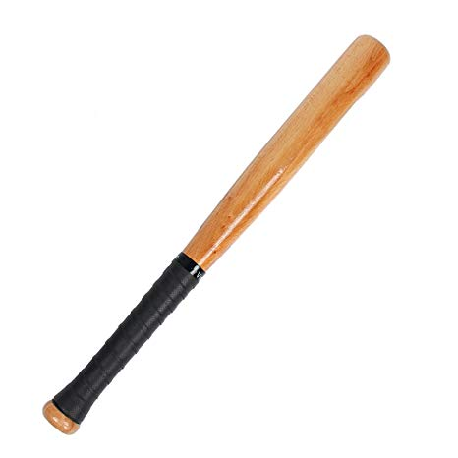

**bat**

**car**

**cat**

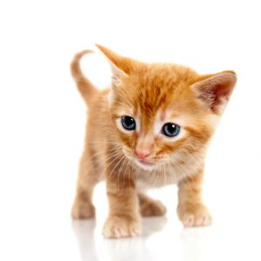

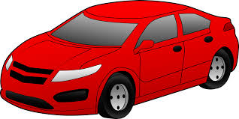

**dog**

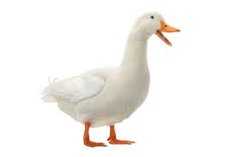

**duck**

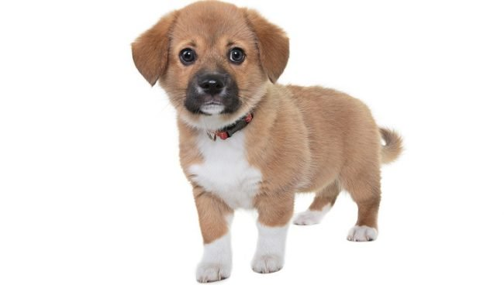

**READING AND WRITING 2**

**🖎** **I/ Write and draw lines to match the first letters**



__uck

b



b

a

c

a

d

c

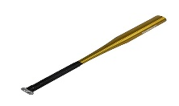

__at

__pple

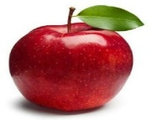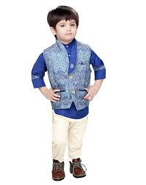

__oy

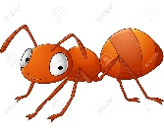

__nt

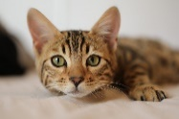

__at

__ ar

🕮 **School things**

**Vocabulary**

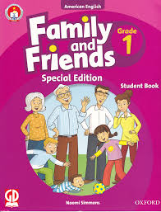  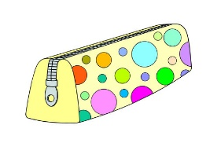 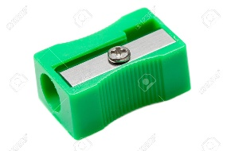

book eraser pen pencil case sharpener

**Sentences**

1. What’s this? It’s a pink book. 
2. What’s this? It’s a blue pen. 
3. What’s this? It’s a green sharpener. 

1. What’s this? It’s a bag. 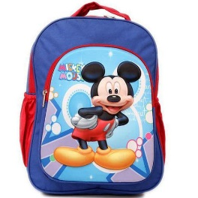

🕮 **Letter E e and F f**

**elephant**

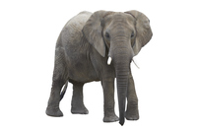

**egg**

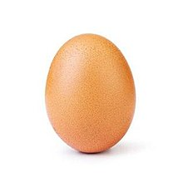

**farm**

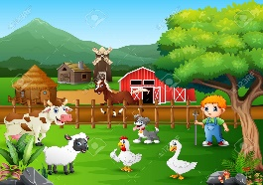

**fish**

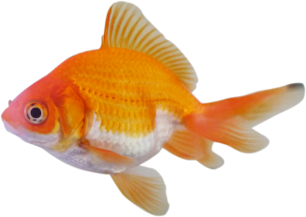

🕮 **Numbers: 1, 2, 3, 4, 5 and 6**

**two**

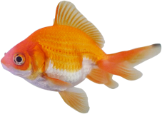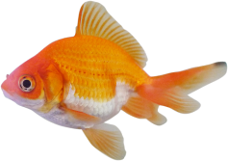

**one**



**three**

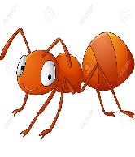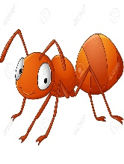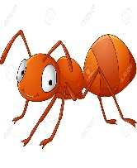



**four**





**six**

**five**

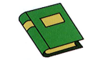

**READING AND WRITING 3**

🖎 **I/** **Complete the pictures. Trace.**

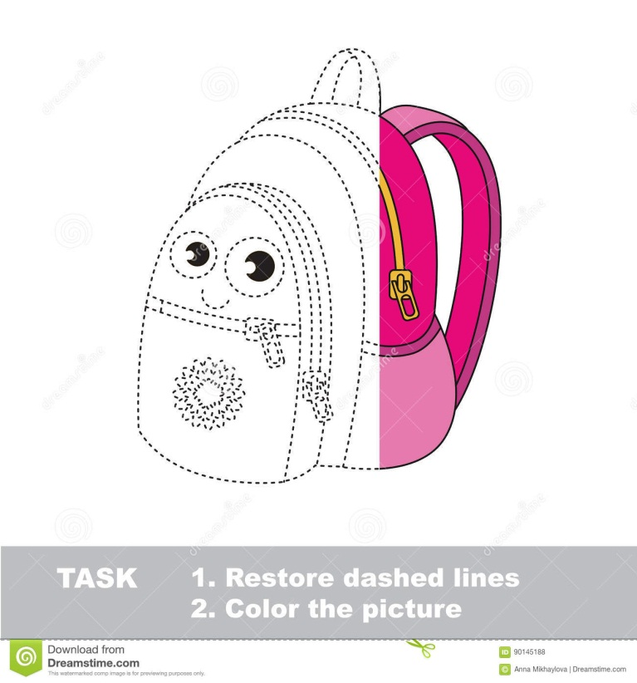 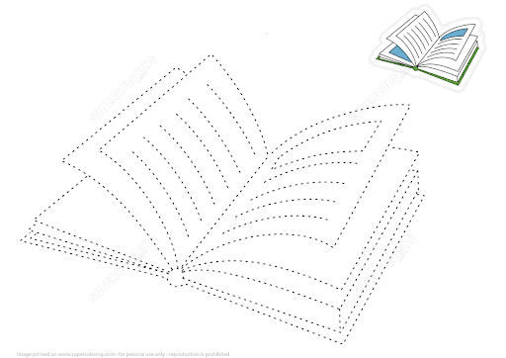

bag notebook

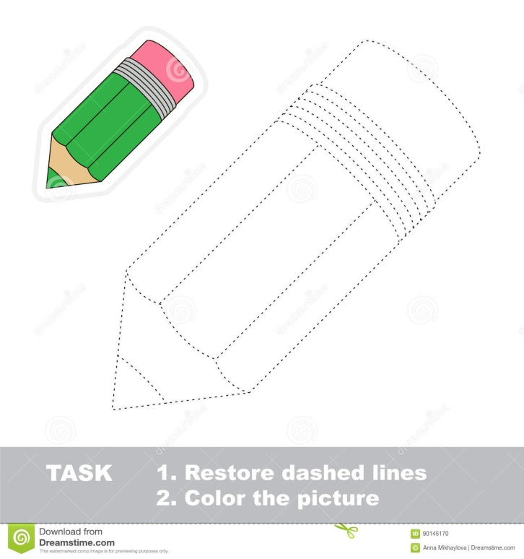 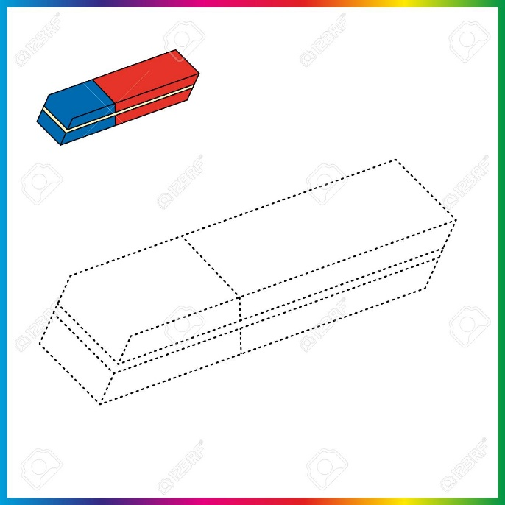

pencil eraser

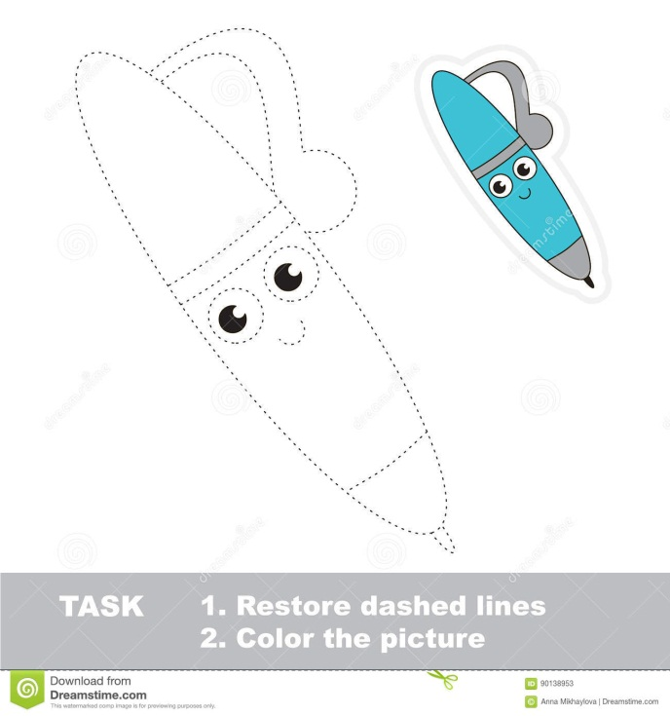 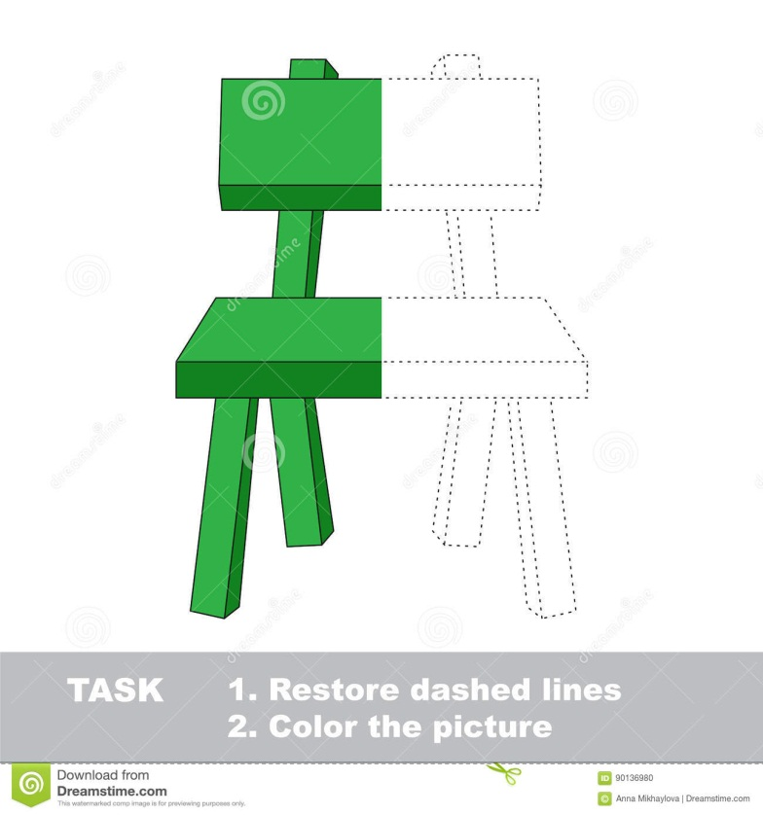

pen chair

**II/ Unscramble the numbers.**

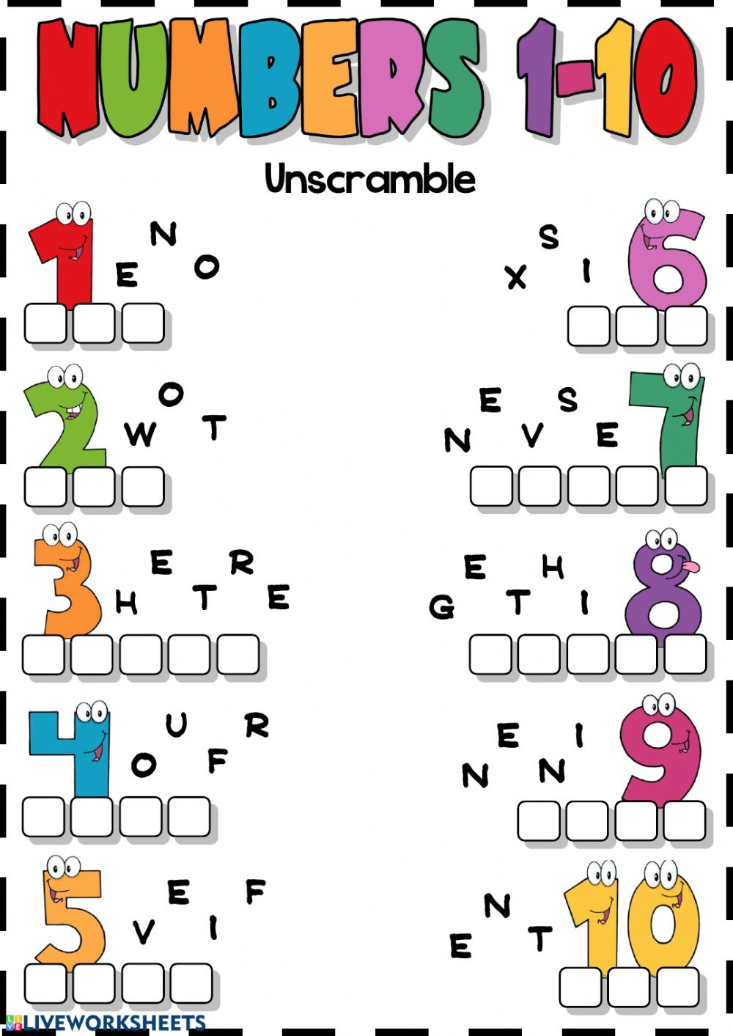

**III/ Count and write the numbers.**

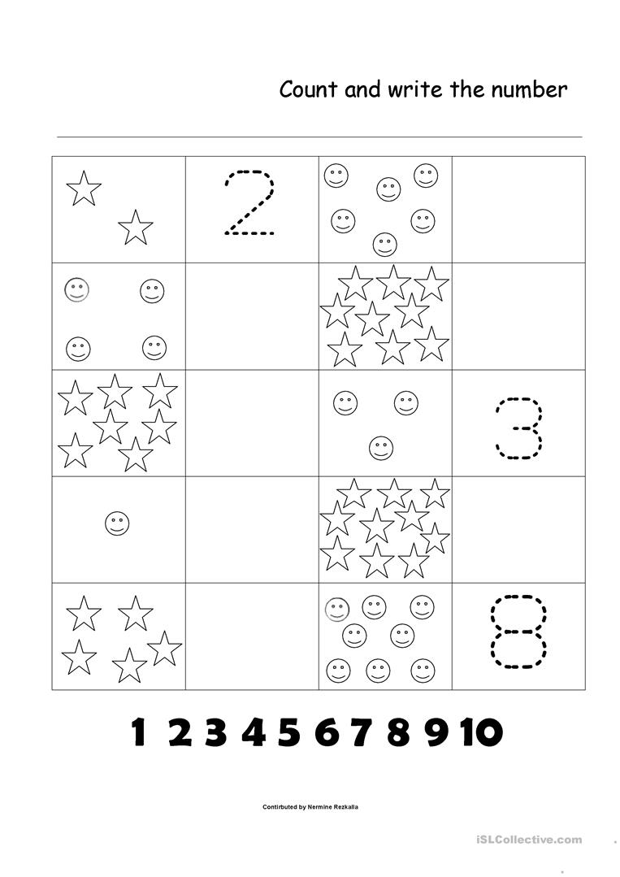

**BÀI ÔN TẬP MÔN ANH VĂN – KHỐI 1**

**Từ 17/02/202020 đến 21/02/2020**

**☺ ĐÁP ÁN**

**READING AND WRITING 1**

**🖎** **I/ Answer the questions**

1. It's yellow.

2. It's green.

3. It's white.

4. It's black.

5. It's blue.

**🖎 II/ Answer the questions**

1. No, it isn't. 2. Yes, it is.

3. Yes, it is. 4. No, it isn't.

5. No, it isn't. 6. No, it isn't.

7. No, it isn't. 7. No, it isn't.

9. Yes, it is.

**READING AND WRITING 2**

**🖎** **I/ Write and draw lines to match the first letters**



__uck

b



b

a

c

a

d

c



__at

__pple



__oy



__nt



__at

__ ar

**READING AND WRITING 3**

**II/ Unscramble the numbers.**

1 one 6 six

2 two 7 seven

3 three 8 eight

4 four 9 nine

5 five 10 ten

**III/ Count and write the numbers.**



6

5

10

1

7

4

9